Maps & Geolocation APIs

🗺️ What Are Maps & Geolocation APIs?
# Source: Chatgpt (GPT-5-Mini) at [1/19/2026]
Maps & Geolocation APIs are web service APIs that provide map visuals, location data, directions, geocoding, distance calculations, and more. They allow developers to integrate interactive maps, location search, and real-time positioning into web or mobile applications.

✅ Key Features of Maps & Geolocation APIs
# Source: Chatgpt (GPT-5-Mini) at [1/19/2026]
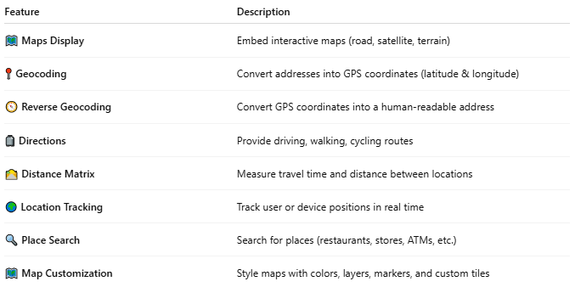

Feature | Description
🗺️ Maps Display | Embed interactive maps (road, satellite, terrain)
📍 Geocoding | Convert addresses into GPS coordinates (latitude & longitude)
🧭 Reverse Geocoding | Convert GPS coordinates into a human-readable address
🧳 Directions | Provide driving, walking, cycling routes
🛣️ Distance Matrix | Measure travel time and distance between locations
🌍 Location Tracking | Track user or device positions in real time
🔍 Place Search | Search for places (restaurants, stores, ATMs, etc.)
🗺️ Map Customization | Style maps with colors, layers, markers, and custom tiles

🧩 Popular Maps & Geolocation APIs
# Source: Chatgpt (GPT-5-Mini) at [1/19/2026]
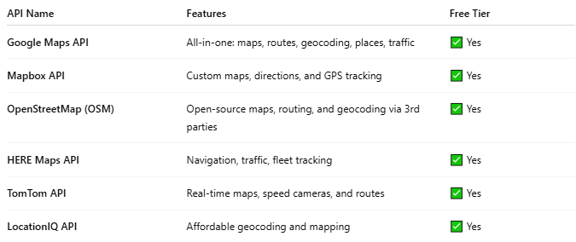

API Name | Features | Free Tier
Google Maps API | All-in-one: maps, routes, geocoding, places, traffic | ✅ Yes
Mapbox API | Custom maps, directions, and GPS tracking | ✅ Yes
OpenStreetMap (OSM) | Open-source maps, routing, and geocoding via 3rd parties | ✅ Yes
HERE Maps API | Navigation, traffic, fleet tracking | ✅ Yes
TomTom API | Real-time maps, speed cameras, and routes | ✅ Yes
LocationIQ API | Affordable geocoding and mapping | ✅ Yes

📍 Example: Google Maps Geocoding API
# Source: Chatgpt (GPT-5-Mini) at [1/19/2026]
Request (Address to Coordinates):
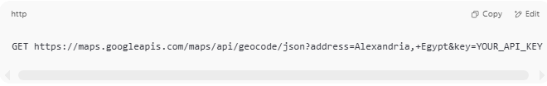
GET https://maps.googleapis.com/maps/api/geocode/json?address=Alexandria,+Egypt&key=YOUR_API_KEY

Response:
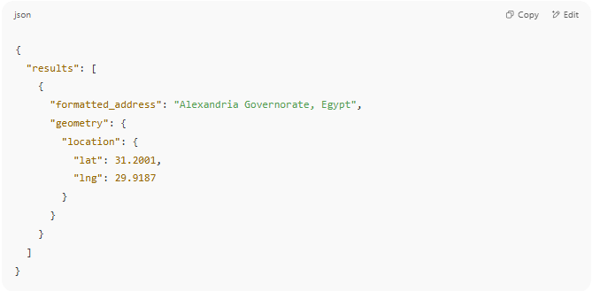
{
"results": [
{
"formatted_address": "Alexandria Governorate, Egypt",
"geometry": {
"location": {
"lat": 31.2001,
"lng": 29.9187
}
}
}
]
}

📦 Real Use Cases
# Source: Chatgpt (GPT-5-Mini) at [1/19/2026]
- Food delivery apps (track driver location)
- Travel & tourism sites (map attractions)
- Taxi apps like Uber (routing, pricing by distance)
- Store locator pages
- Real-time GPS-based notifications

🛠️ Map Embedding (Simple Example - Google Maps)
# Source: Chatgpt (GPT-5-Mini) at [1/19/2026]
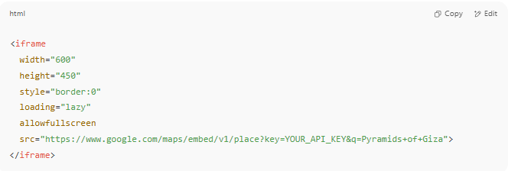
<iframe
width="600"
height="450"
style="border:0"
loading="lazy"
allowfullscreen
src="https://www.google.com/maps/embed/v1/place?key=YOUR_API_KEY&q=Pyramids+of+Giza">
</iframe>

